“Banana Properties” – Banana Shire, QLD
Expression of Interest

The Indigenous Land and Sea Corporation (ILSC) is inviting expressions of interest from Indigenous organisations who have the vision and ability to generate benefits for Indigenous people through the ownership of Mindanao, Tiamby and Somerset, collectively referred to as The Banana Properties.
The Banana Properties are three properties located in the Capricornia region of Central Queensland, in and around the town of Banana. Combined the properties total 4,409 Hectares, through five parcels of freehold land. These properties were previously used as part of cattle operations conducted by the ILSC subsidiary – Primary Partners (formally Australian Indigenous Agribusiness) and have more recently been leased to other operators. The properties are predominately cleared land with improved pasture and are well equipped to support their primary use of pastoral activities.
The ILSC is seeking to divest these three properties to an Indigenous-controlled incorporated entity who has demonstrated capability and strong governance to effectively own and manage these properties for the benefit of Indigenous people.
Applicants can find further information of property details in the below property profile.
The Expression of Interest Process:
The ILSC is seeking expressions of interest from Indigenous organisations who have the skills and vision to effectively own and manage The Banana Properties. In particular, the process aims to:
- Identify a future landowner in which the ILSC can divest The Banana Properties
- Provide an opportunity for applicants to outline how activities on the properties will generate economic, social, environmental and cultural benefits for Indigenous people
- Provide an opportunity for applicants to outline their capability and capacity to effectively own and operate the properties
Indigenous organisations are invited to submit expressions of interests, with shortlisted candidates then invited to provide more detailed proposals, including detailed business plans and financial forecasts. Shortlisted entities will also be given the opportunity to inspect the properties.

How we will assess your application
The Expression of Interest (EoI) is a competitive process. This process involves your EoI being assessed against each of the criteria set out in the application form (summarised below) and against other EoI’s received by the ILSC.
At a minimum, the ILSC would expect each applicant to provide the following:
- Outline of the proposed use of the properties and how this will benefit Indigenous people in the region (opportunities and outcomes)
- Details of how the proposed land use will ensure the properties remain viable (project viability)
- Details of existing capability and experience to manage the land (capability)
- Details of the applicants current financial health and ability to fund activities to be conducted on the properties (financial health)
- Details of the applicant’s governance structure, functions and obligations and its suitability to receive land from the ILSC

How to apply
To express your interest, please complete the Expression of Interest Application Form.

Expression of Interest timeframes
- Expressions of Interest can be submitted up to and including the 14th of January 2022
- Shortlisted applicants will be advised shortly after the Expression of Interest closing date, with opportunity given to conduct property inspections
All submissions must be lodged using the supplied – ILSC Expression of Interest Application Form and submitted via Email: EasternOffice@ilsc.gov.au
For further information, including requests for a property inspection, please contact Eastern Division Office on: 07 3854 4664.

Property details

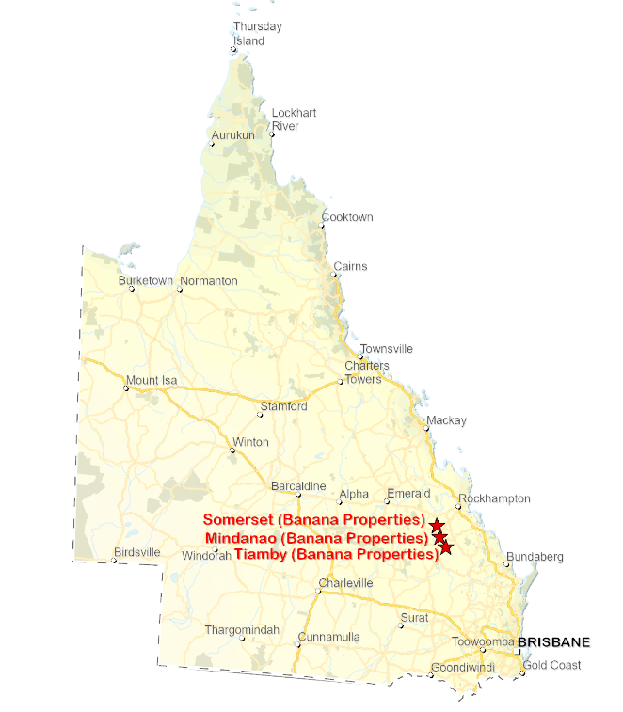

Mindanao Property Profile
Location | 145 Brackens Road via Banana (20km NW of Banana)
Size | 1,380 hectares
Tenure | Freehold
Parcels | - Lot 39 on Crown Plan FN305 Title Reference 50912875  - Lot 40 on Crown Plan FN305 Title Reference 17764061
Background | Mindanao is a 1,380-hectare property across two parcels of land. The land is fully cleared and developed with improved pasture. The property contains a house and workers quarters which were refurbished in 2018. There are good quality yards and waters on property.  The ILSC ran pastoral operations on Mindanao through its subsidiary – Australian Indigenous Agribusiness - up until 2018 when the decision was made for the ILSC and its subsidiaries to transition away from being a principal operator. The property was sub-leased following the ILSC’s operational exit but is now available as vacant possession.
Property map | 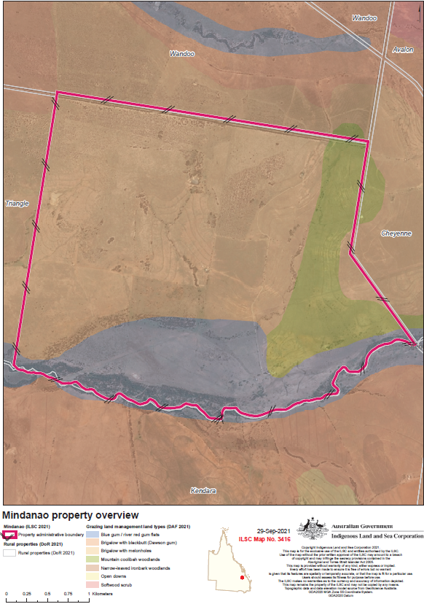
Assets, infrastructure and conditions | Accommodation  A homestead with refurbished kitchen and bedroom.  Workers quarters that include a 2 bedroom donga with kitchen and dining room facilities  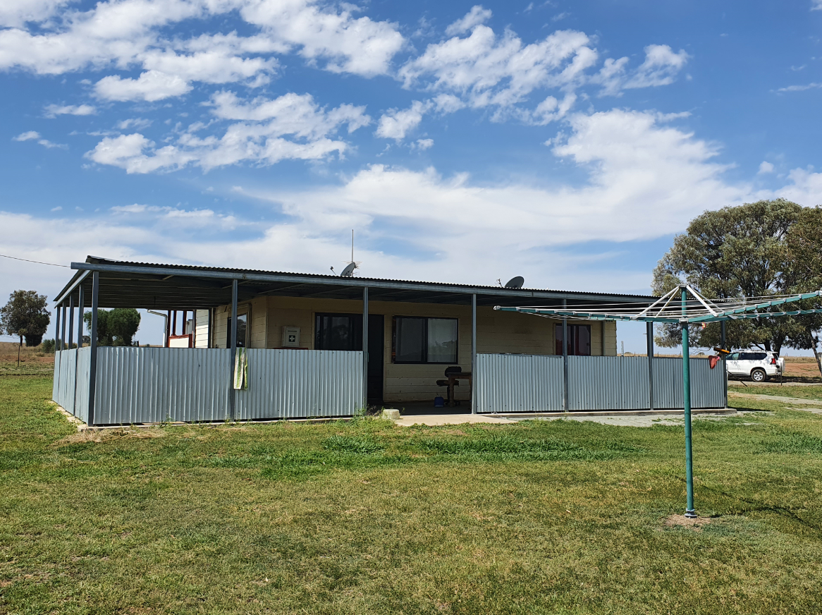  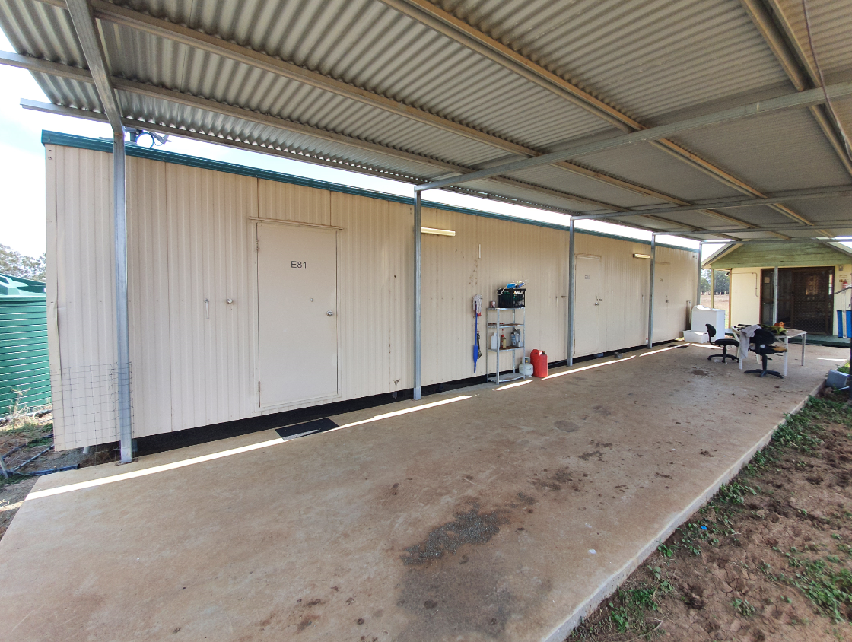  Property infrastructure  Fencing, cattle yards, troughs, and pumps in good working order  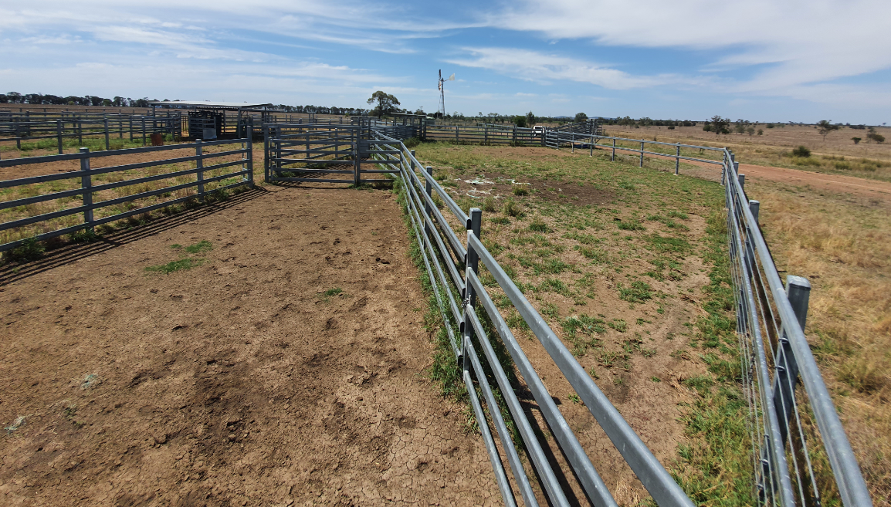  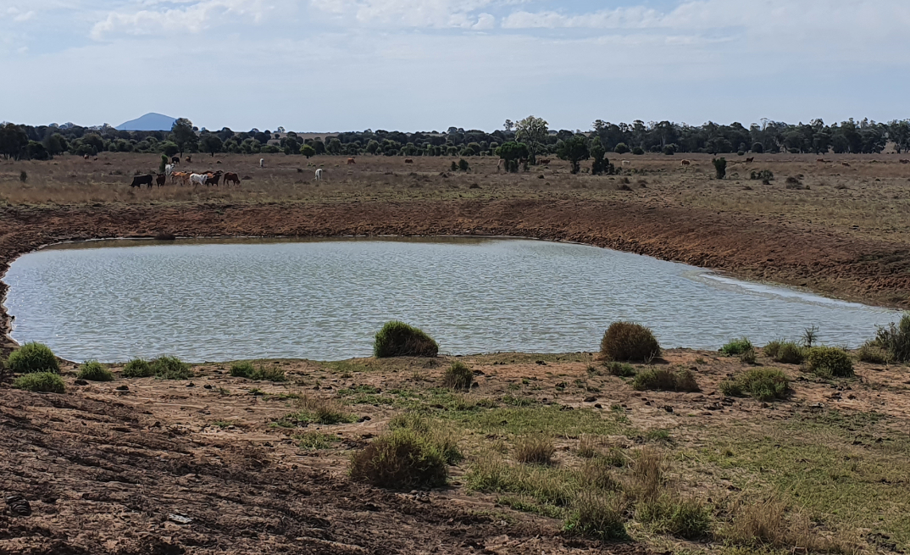  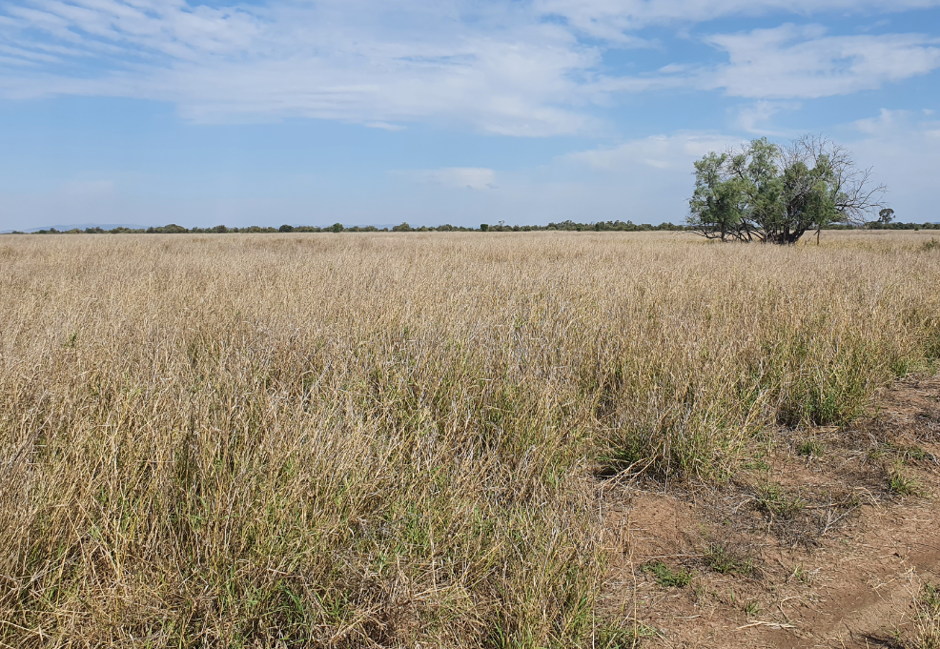

Tiamby Property Profile
Location | 3110 Barfield Road and 2851 Barfield Road (30km SE of Banana, 35KM NE of Theodore)
Size | 1,722 hectares
Tenure | Freehold
Parcels | - Lot 17 Crown Plan DW283 Title Reference 50382268  - Lot 18 Crown Plan DW285 Title Reference 50382340
Background | Tiamby is a 1,722-hectare property across two parcels of land located at 3110 Barfield Road and 2851 Barfield Road (20km SE of Banana). The property is a mixture of brigalow and softwood scrub. The property has fencing and water infrastructure that is in good condition. No livable housing or workers quarters are on the property.  The ILSC ran pastoral operations on Tiamby through its subsidiary – Australian Indigenous Agribusiness - up until 2018 when the decision was made for the ILSC and its subsidiaries to transition away from being a principal operator. The property was sub-leased following the ILSC’s operational exit but is now available as vacant possession.
Property map | 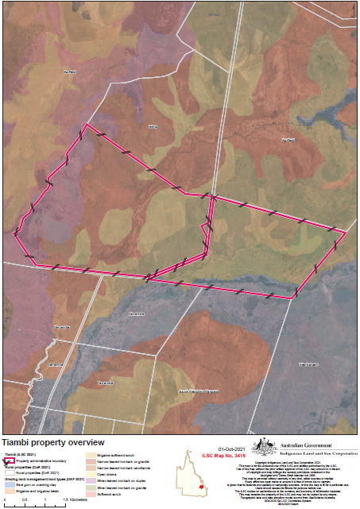
Assets, infrastructure and conditions | Accommodation  The property has no usable accommodation  Property infrastructure  Yards, fencing, tanks, troughs, and pumps in good working order  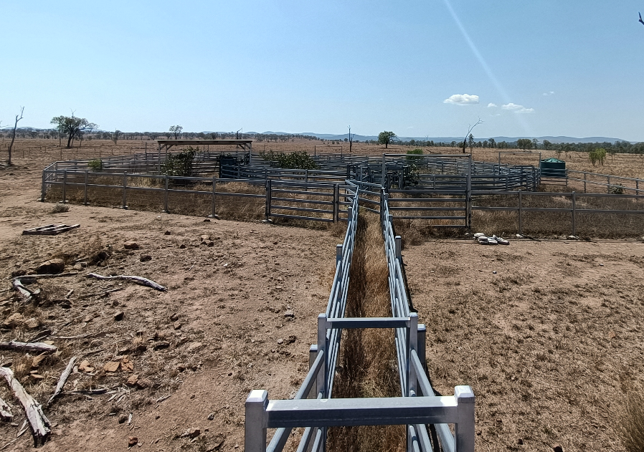  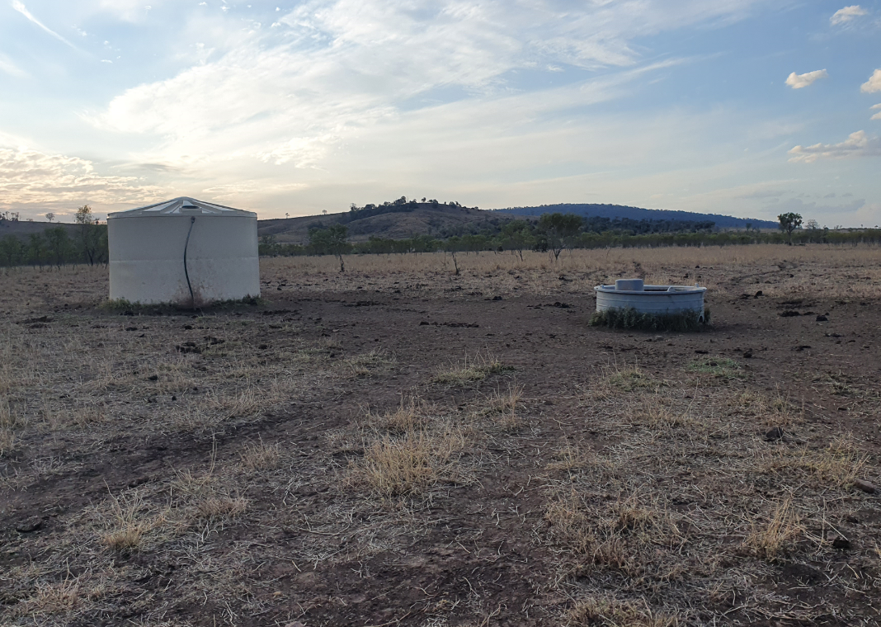

Somerset Property Profile
Location | Olinda Road via Baralaba (40 km NW of Banana)
Size | 1,307 hectares
Tenure | Freehold
Parcels | - Lot 17 on Crown Plan FN162 Title Reference 30632129
Background | Somerset is a 1,307-hectare property across one parcel of land located at Olinda Road via Baralaba (40 km NW of Banana). The property is set up for cattle grazing and is predominately cleared brigalow country with good fencing and water infrastructure on site. The property has shedding suitable for housing machinery, but no on-site accommodation adequate for living.  The ILSC ran pastoral operations on Somerset through its subsidiary – Australian Indigenous Agribusiness - up until 2018 when the decision was made for the ILSC and its subsidiaries to transition away from being a principal operator. The property currently has a tenant who holds the property through a Licence Agreement. This is a five-year agreement with a 2023 expiry.
Property map | 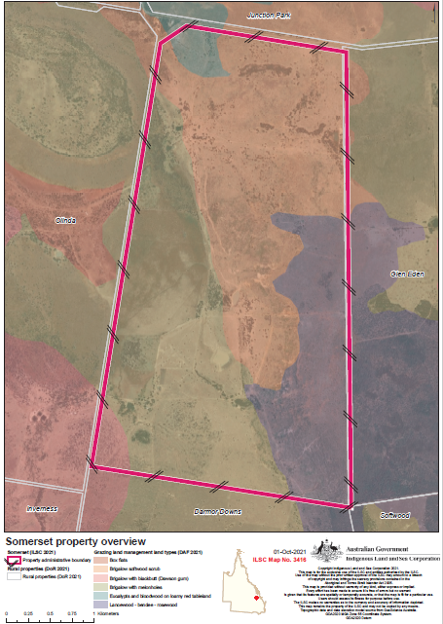
Assets, infrastructure and conditions | Accommodation  The property has no liveable accommodation  Property infrastructure  Machinery shed, fencing, tanks, troughs and cattle yards in good working order. Multiple dams have recently undergone improvements through de-silting and enlargement  